Documentation for use of Code_generator application

1-here the link for my repo <https://github.com/progzidan2018/code_generator_api.git>

2-clone or download it

3-create DB called crud_system

4-run command php artisan migrate

5-run the command php artisan serve

6-register new user

7-open postman

8-run this following post request <http://localhost:8000/oauth/token> to get the access token for this api

and fill out these body fields

key value

8.1- grant_type password

8-2- client_id 2

8.3- client_secret this will be obtained from oauth_clients table

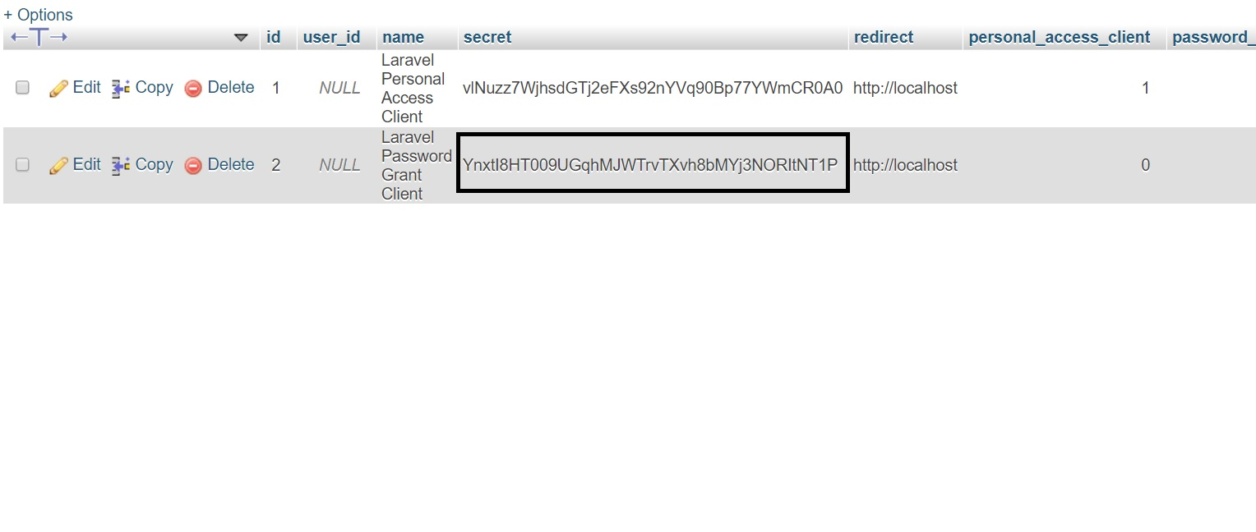

8.4- username username that u registered ex: a@a.com

8.5- password password for this user ex: 123456

and send the request and u will get this access_token

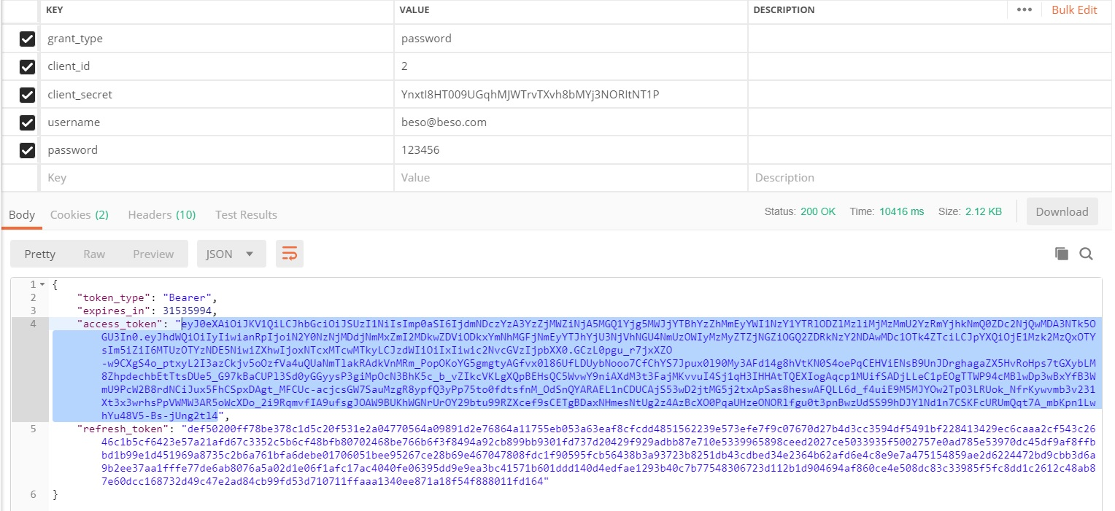

9-create new post request with url <http://localhost:8000/api/generate> and fill these header fields out

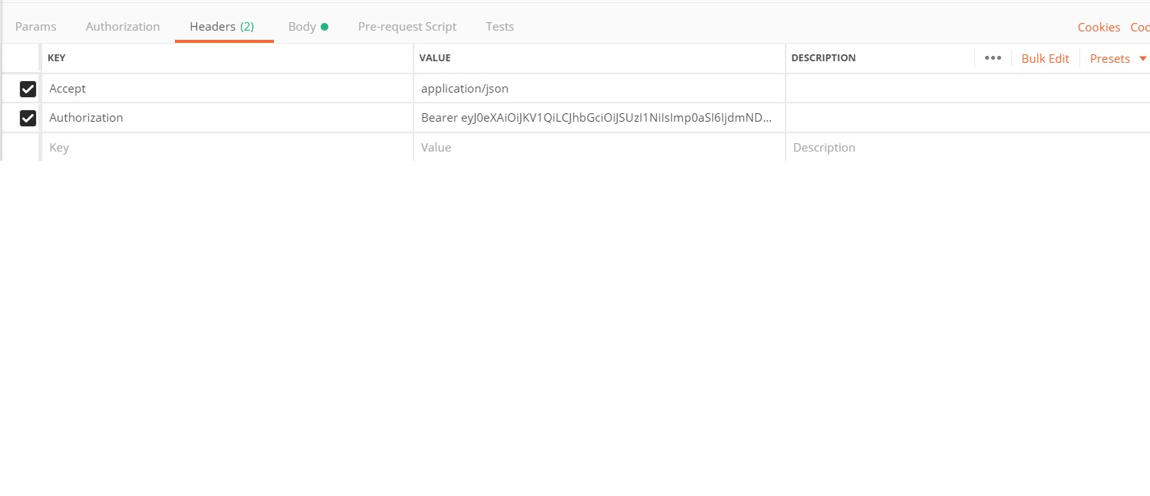

key value

9.1- Accept application/json

9.2- Authorization Bearer and past access_token

10-fill these body fields out

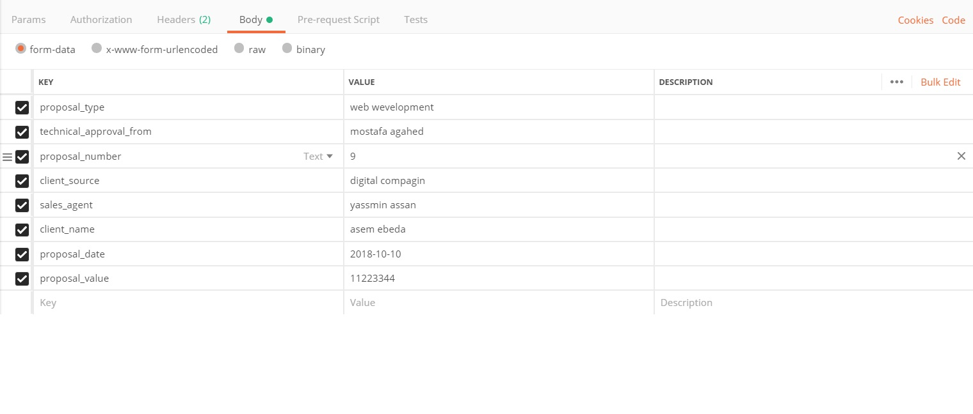

and the output after sending this post request the output will be like this

